

User Guide

In Admin panel you need to enable this module under
store > configuration > Sales > Shipping method > KuebixApi

There is one option to enable/disable module If enable the Kuebix Api then select Yes And fill the all-configuration data

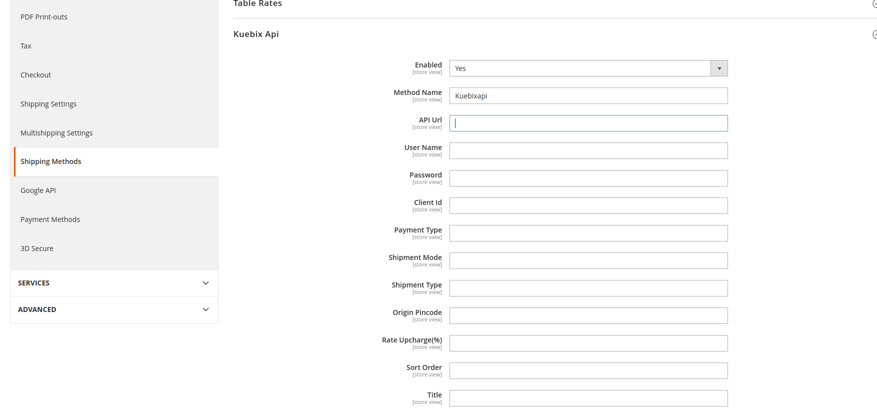

There are two fields product weight and Freight class are required field to work this module. Kindly add Weight and Select Freight Class under Catalog->Products->Add/Edit Products

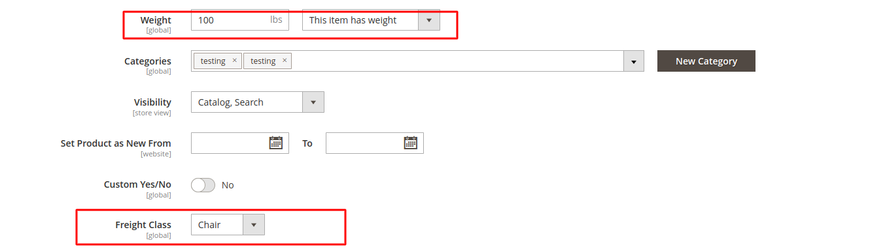

Kuebix Shipping method on the checkout page

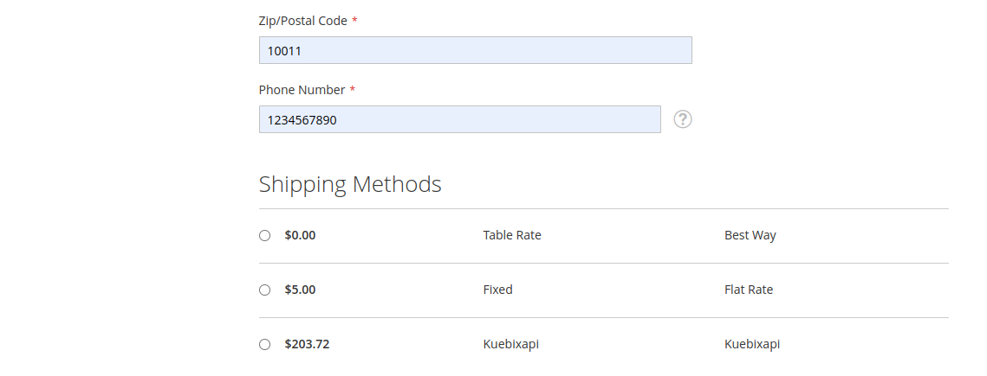

Kuebix shipping method on payment page.

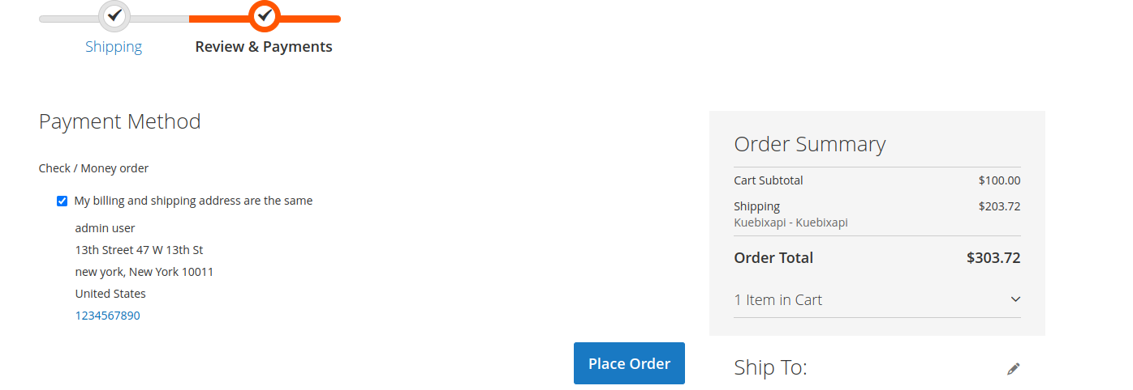

Kuebix api data on Sales order view page in admin section.

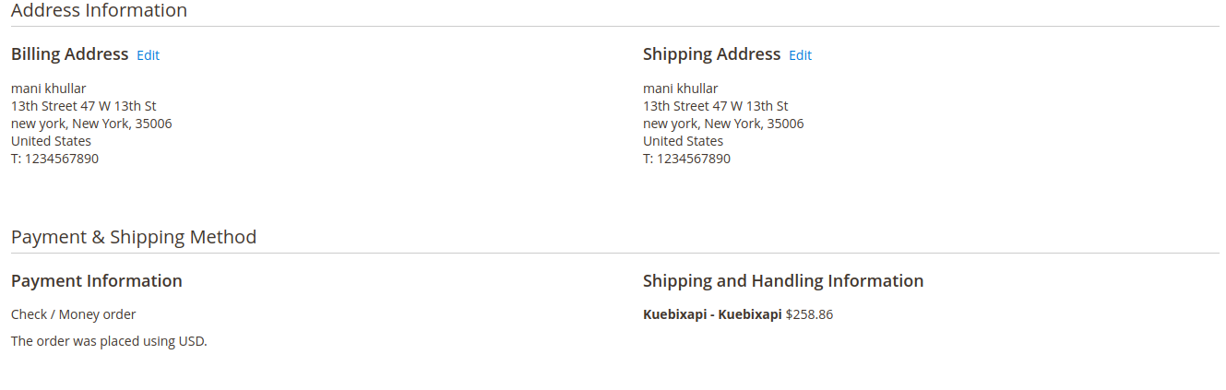

Kuebix api data on Sales order Invoice view page in admin section.

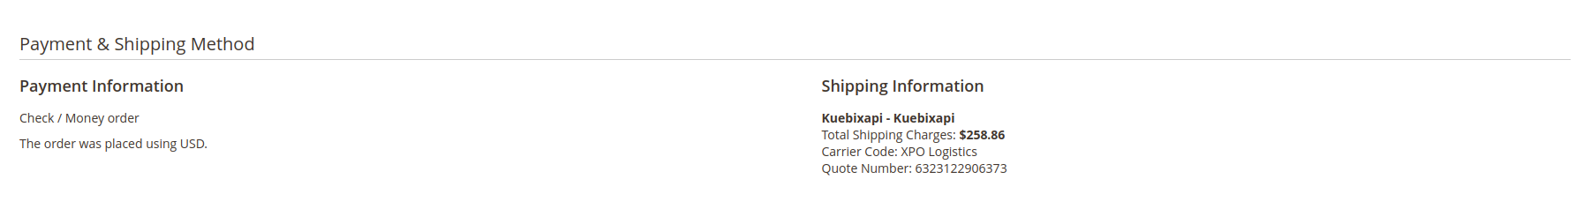

Kuebix api data on Sales order Shipment view page in admin section.

